DSN (Domain name service):

Ip system for human understanding k lye h device convert inti binary

Hum hamesha devices koi p addr se undertstnad krtey h with the growth of net ip add insan k lye yad rkhna is muskil hogaya toh dns humra url koi p address m resolve krta h

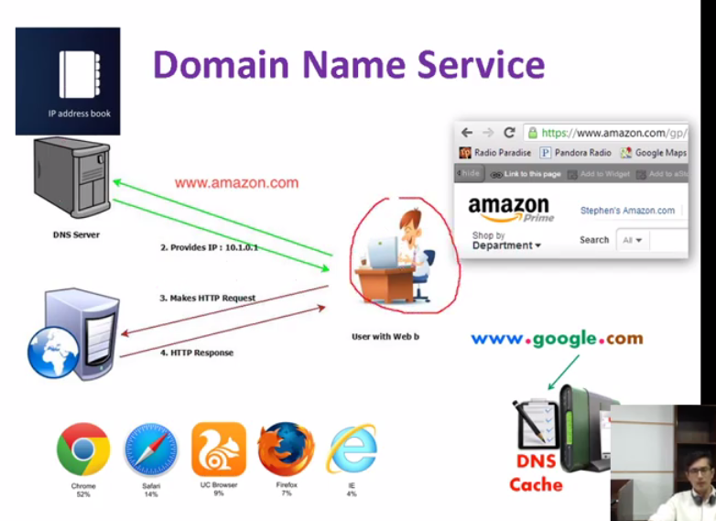

User call website .so servser yeh query dns k pass le kr jataa h toh humre pass addr book hoti h jis m ip address or us k nm hotey yani url wagera

Jo amazon k samne sth ip addr hoga wo khulegaa

DNS: domain ---------IP

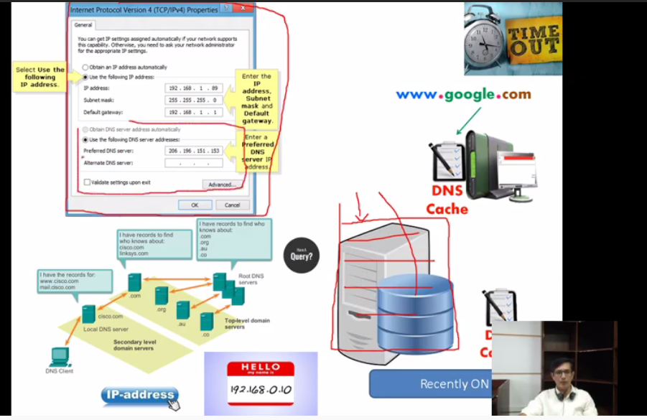

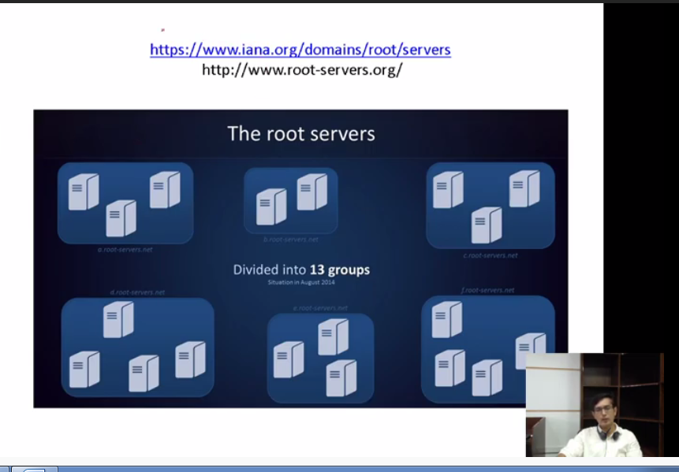

13 groups m h jse .com

.net

.pk

har region k lihaz se h

dns ki query jati h us k behave pe ip convert hoti h 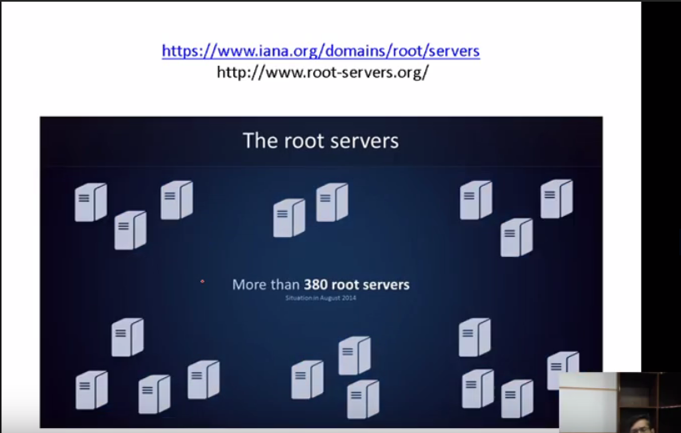

LAB:

Ips k pass bh dns server h .. jo local website wagera ko manage krti h

Root server ko inaya manage krti h

Pc ko direct ip se req bhjdegy

Pc se direct website kpe cisco agar open nh hoga toh hum dns server m salegy phir agar use cisco.com pe jaan hoga toh dns server btayega k han yeh h or agar nh h toh ip address aagr nh hoga toh reject krdega packet

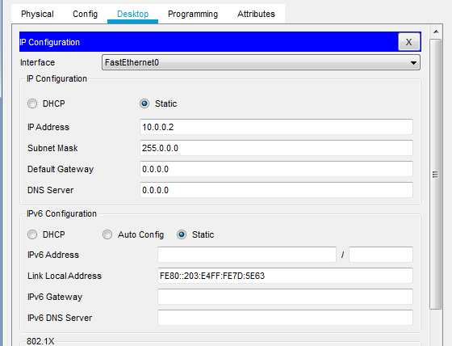

Abhi koi dns serve nh h

With ip:

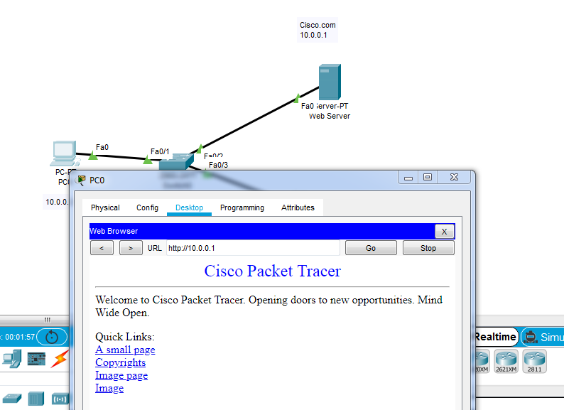

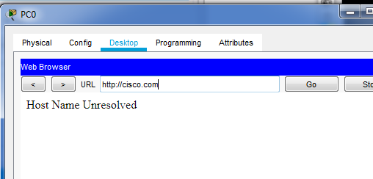

DNS Server:

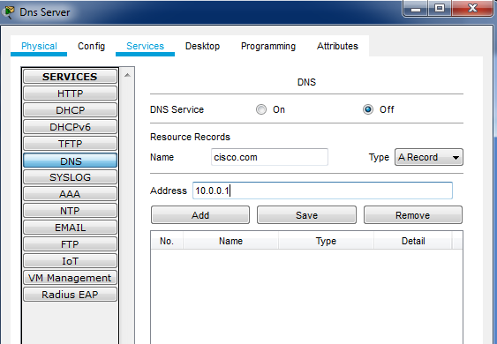

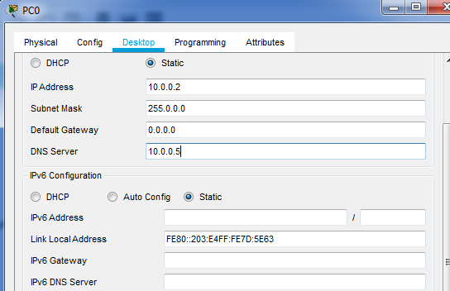

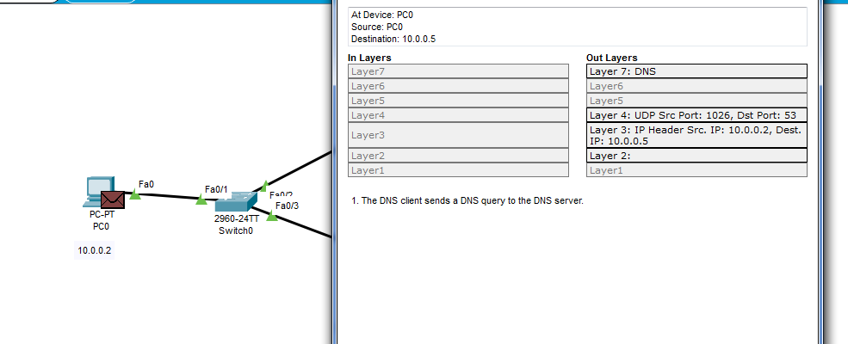

Dns wordk udp port 53

Ab next http ki req jayegi ab use pata h chl gaya h cisco.com 10.0.01 hai ab htt jayega cisco k pasd

System k andar ki dns book: ipconfig /displaydns

Dns cache

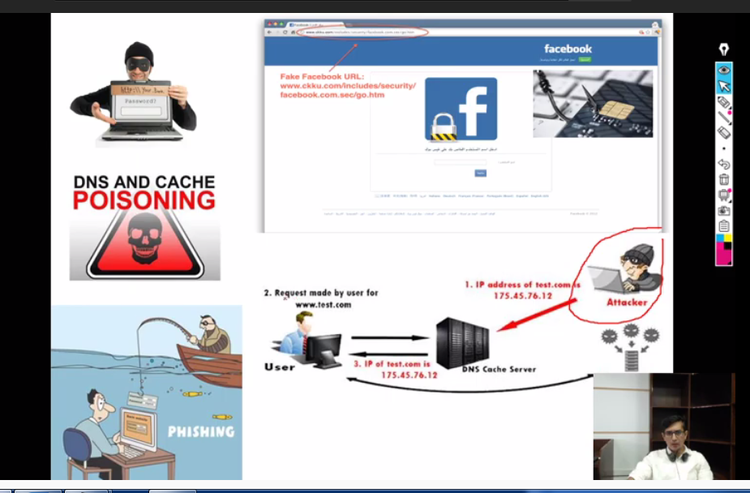

Attacker is k cache m ip address chang ekrdegaa copy website phising attack

Test.com ya fb.com ki jaagh apne phisling website daldo mirrior ueve hogi

To ipconfig /dnsflush se clear kardena chahye

Yahan cache book hoti h : C:\Windows\System32\drivers\etc

FTP(File transfer protcols): 21 port

n/w m pc wagera m ..windows krne hoti h formate update krne hoti h ya toh m use kse usb ya drive pe daldo ya wo ftp k server pe dump kardo or direct wahan se le kr cages kardo

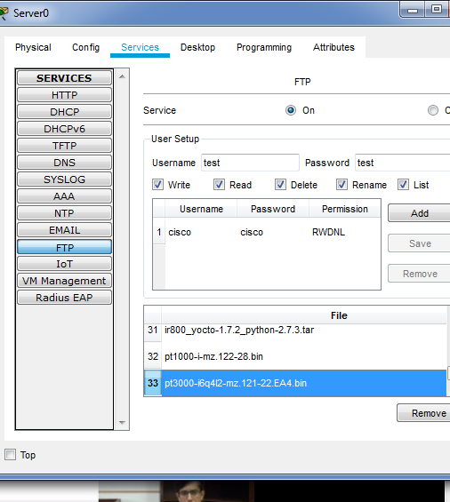

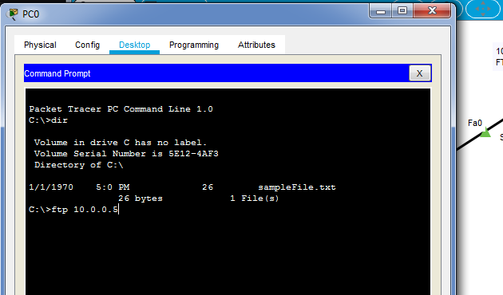

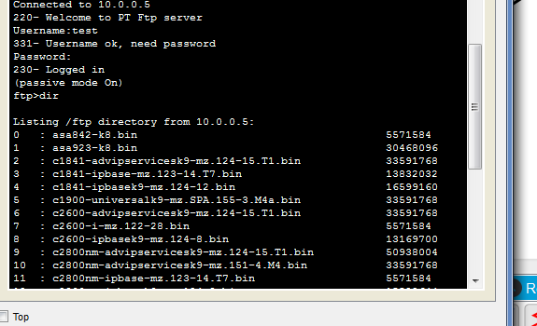

🡪get c2960-lanbase-mz.122-25.FX.bin

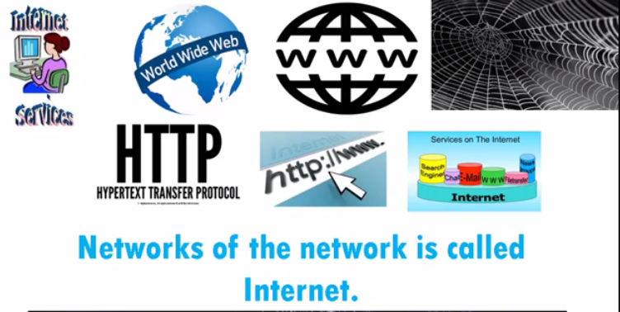

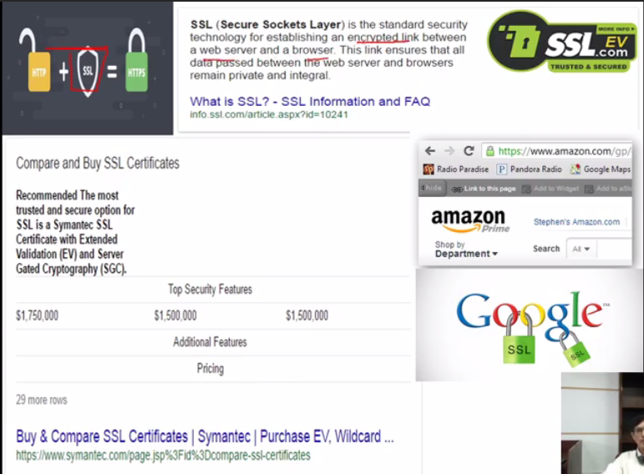

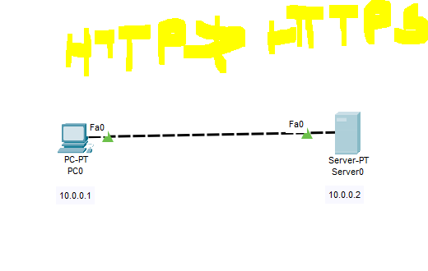



Domain name to ip address resolve krta h

Comm k lye we have 2 addr ip and mac

Ip addr static/dhcp

But how to know their mac addr

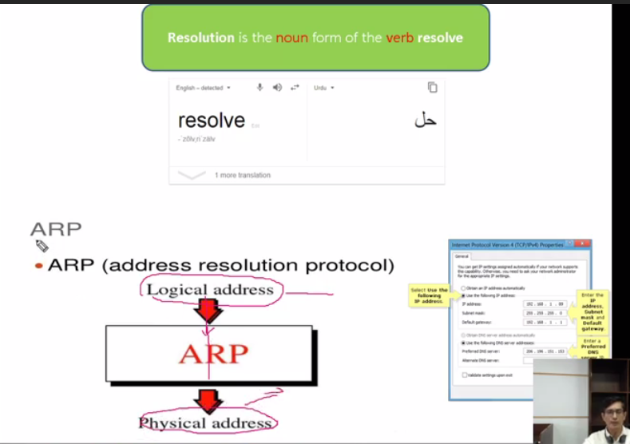

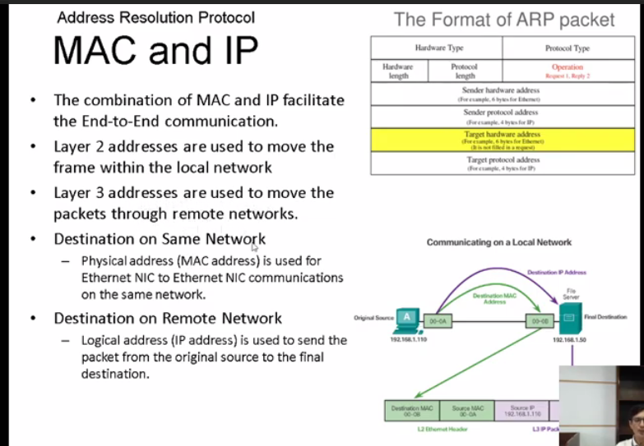

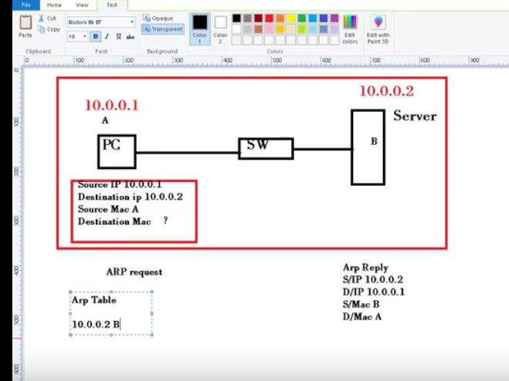

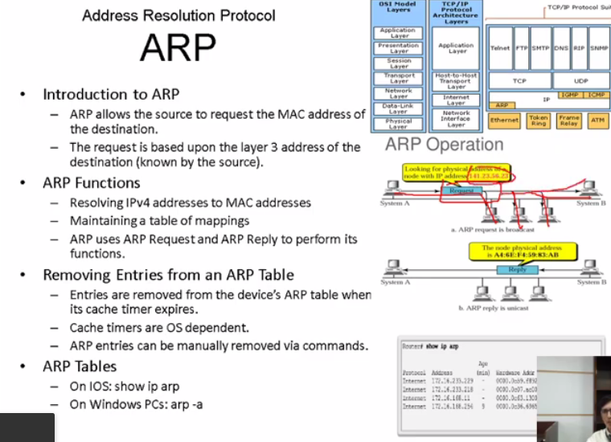

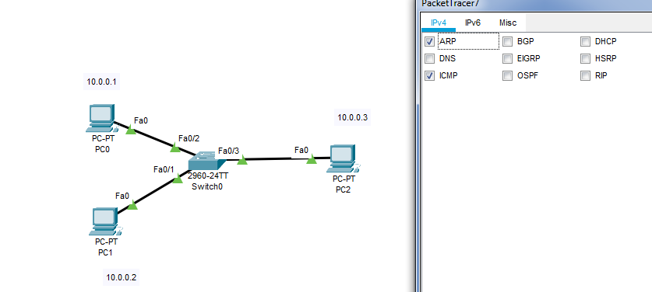

Abhi hum within same n/w parrhe h

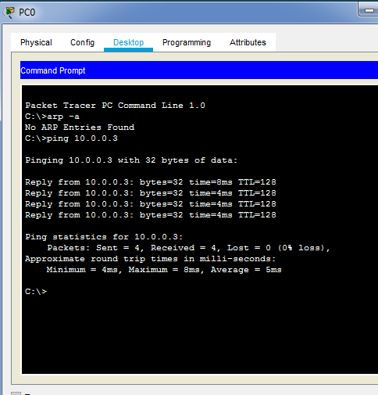

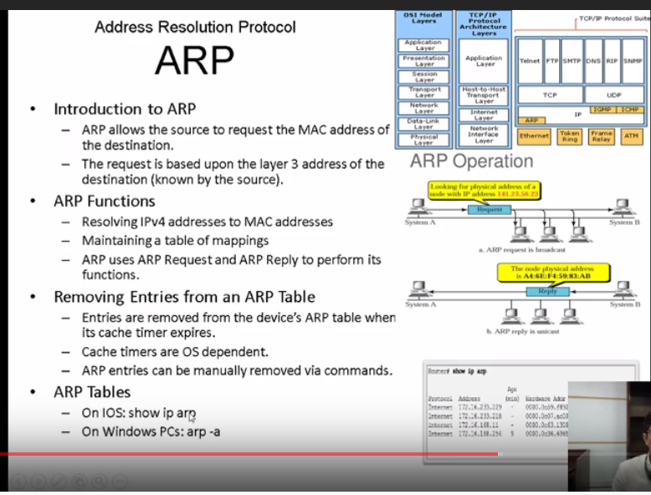

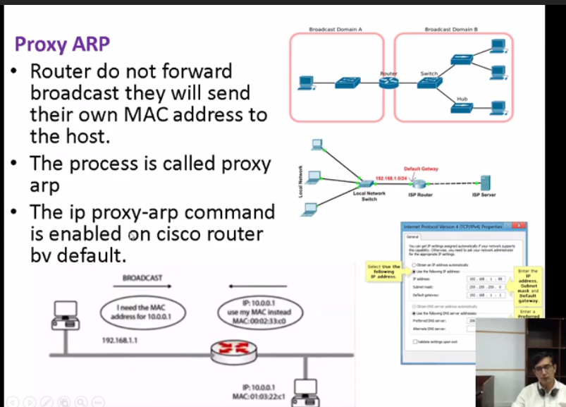

5 types of arp h

If dest kse dosre n/w m ho toh wo alag resolve hoga qk brach m router h arp broadcast krta h par router broadcast block krdeta h

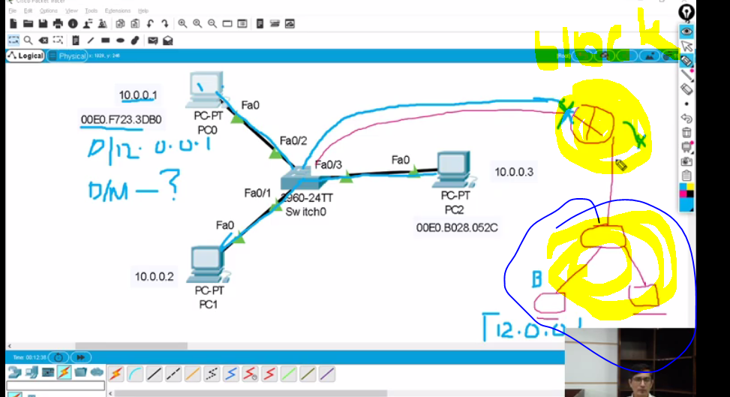

Bikl asaan h bas gateway dedo router pe like 10.0.0.0 dedo

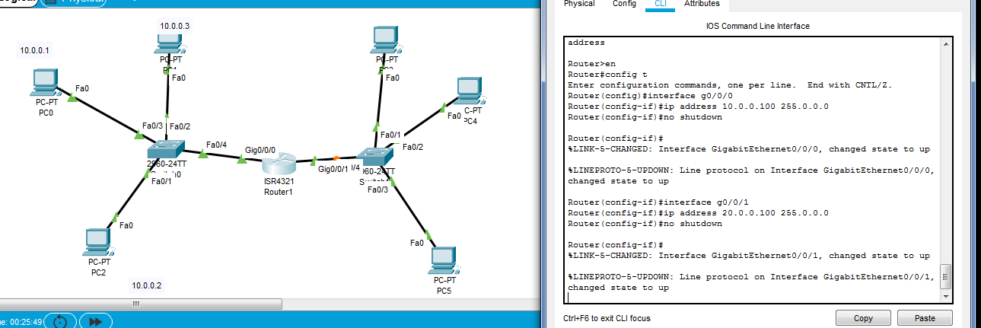

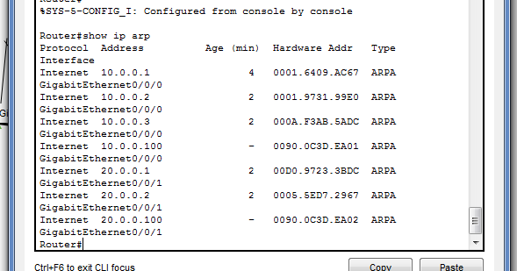

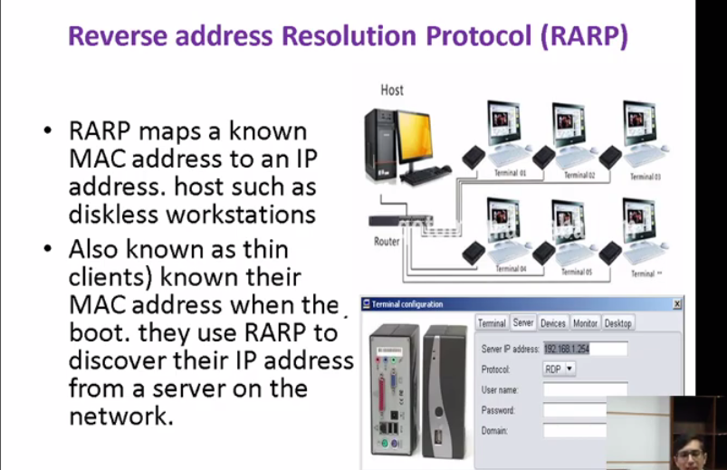

Mac address to ip address

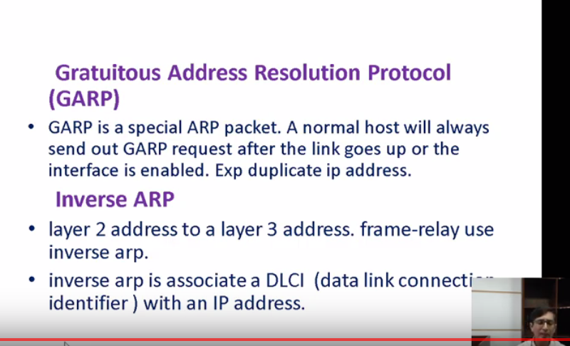

Like RARP l2 pe dlci wagera use hotey h l2 se l3 resolvekrne k lye use hoti h

GARP:

Yeh dkhlta h k ip addrdup ha h ya nh yeh jab dkhta h jab hum dynamically ip addr dete h

Mtlb simple sab k ip addr alag alag ho

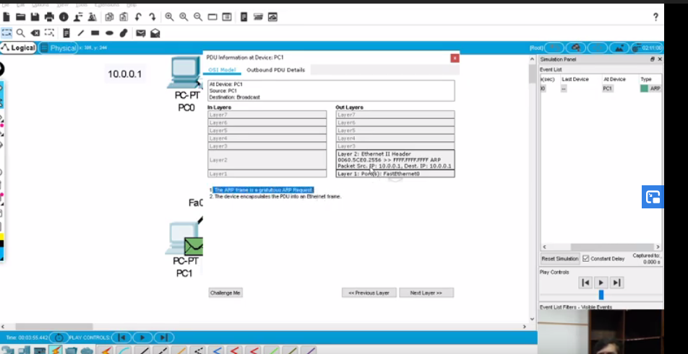

Src or sdt add same h agar dst m 10.0.0.1 h toh paat chl jayegaa k yeh m use krrh ho toh tm use nh sktey h

